

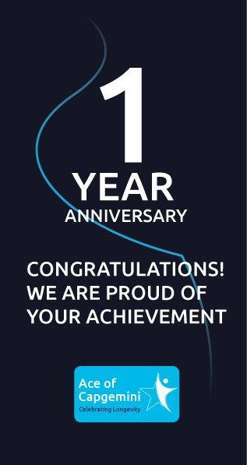CERTIFICATE

OF APPRECIATION

is proudly present ed to

Ankita Chavan

In recognition of your 1 year *or* valuable service at Capgemini.

#GetTheFutureYouWant

Awarded on 7 April 2023

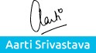

 CEO - India, Capgemini